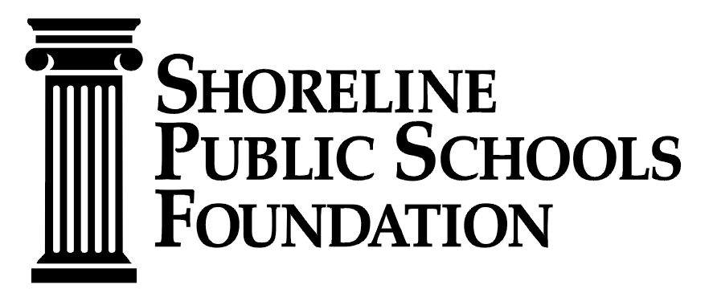 2022-2023 ENGAGEMENT GRANT GUIDELINES

MISSION
The Shoreline Public Schools Foundation funds opportunities for educational success.

CRITERIA

- Request must echo the Foundation’s mission
- Grant must apply to one of the categories listed below
- Shows greatest impact on student learning and achievement
- Demonstrates integration of curriculum
- Grant must take place during the current school year
- Funding request is beyond the financial limits of the District

GRANT CATEGORIES

Bridging the Opportunity Gap – Our goal is to fund support to help students reach their full potential.

Diversity, Equity & Inclusion – Provide funds for curriculum, activities, and projects that will uncover, recognize, empower, and support students of color.

Science, Technology*, Engineering, Arts and Math – Funding curricula and programs to enhance student development and readiness in these disciplines. *Any technology purchases must be pre-approved by the District’s Technology Department to guarantee that it can be supported.

AWARD LEVELS FOR BOOKS

- $250 per classroom

- $500 for one grade level

- $1,000 for a building library

*This doesn’t apply to books and resources used for curriculum.

APPLICANT RESPONSIBILITIES
- Must use the online application form only
- Application must be approved by an Administrator
- Applicant must choose one grant category
- Application must provide a detailed budget
- Applicant must illustrate impact on student learning of grant
- Application must be able to measure success of grant

Recipients must fill out evaluation sheet and show impact. Hi-res photos, testimonials, etc. is required and due at the SPSF office by June 16, 2023.

All technology, books, and materials purchased are the property of the Shoreline School District. Labels will be provided. (All items purchased with grant funds are the property of the District and do not become the personal property of the grant recipient.)

Contracted Shoreline School District employees will be paid no more than their current rate. Certificated staff $50/hr + 24% benefits for instruction time and $40/hr + 24% benefits for non-student contact time.

ITEMS NOT FUNDED
- Substitute for staff during student contact time
- Chaperones
- Food unless there is a nutritional student need component
- Capital improvement costs
- Any project or items that qualify for District funds

TIMELINE
Grant applications will be available in JULY 1, 2022. There are two grant cycles. Application must be submitted online by SEPTEMBER 12 or by DECEMBER 16.
Late applications will not be accepted.

This is a competitive process. All applications will be reviewed side-by-side. Notifications will be made no later than September 30 and January 31. Grant funds will be dispersed depending on approved grant specifications.

Direct all questions to Charlene Carlson, Office and Programs Manager at:
206-393-4107 or shoreline.foundation@shorelineschools.org

Shoreline Public Schools Foundation
Room E-500 / Shoreline Center Building
18560 First Avenue NE
Shoreline, WA 98155

